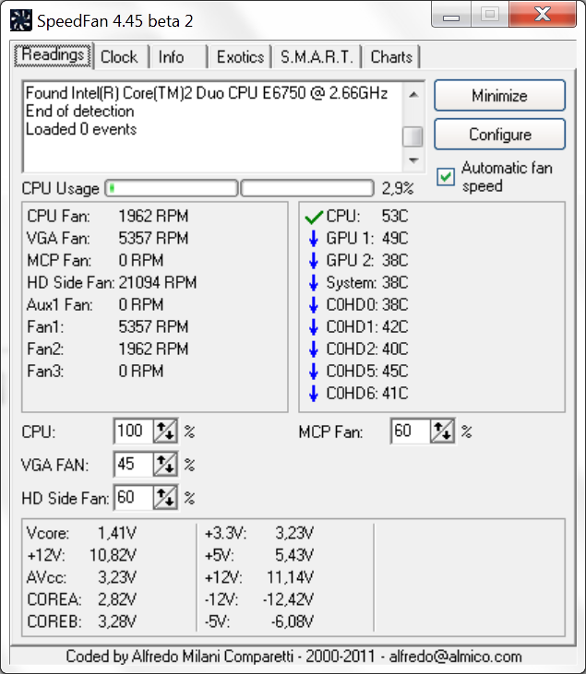
New beta – voltages now seem correct compared to previously
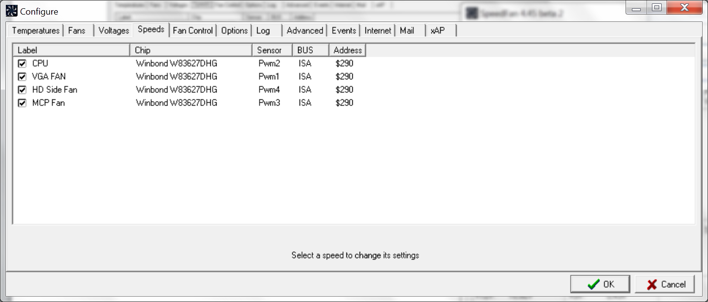
Still no MCP fan discovered… These are 4 of the 6 actual fan connectors in motherboard. (The one named MCP Fan is actually another fan renamed in settings)

Motherboard model EVGA 780i 132-CK-NF78
